**FEBRUARY 2023**

**BSIT 2D (WEB DEV)**

|  |  |  |
| --- | --- | --- |
| **NAME** | **REMARKS** | **SIGNATURE** |
| **MALE** | | |
| 1. ENRIQUEZ, ARMAN S. | PARTICIPATE |  |
| 1. ESTACIO, FRANCIS B. | PARTICIPATE |  |
| 1. FAVO, JOHN PAUL G. | PARTICIPATE |  |
| 1. FRIO, REYMART G. | PARTICIPATE |  |
| 1. GABATINO, LABORIEL A. | PARTICIPATE |  |
| 1. GARCIA, CHRISTOPHER JONES J. | PARTICIPATE |  |
| 1. ISIT, JUSTINE JADE S. | PARTICIPATE |  |
| 1. JALANDOON, JILL ARIEL, JR A. | PARTICIPATE |  |
| 1. KUDERA, ANDREW EIZ JAMES P. | PARTICIPATE |  |
| 1. LANGAS, MELVIN P. | PARTICIPATE |  |
| 1. LAYCO, ENRIQUE C. | IRREGULAR |  |
| 1. LIM, DAVE ANTHONY G. | IRREGULAR |  |
| 13. MARCO, LEO ANGELO B. | PARTICIPATE |  |
| 14.MIRABUENO, CARLO JAY T. | IRREGULAR |  |
| 15.NABUBOS, JEMAR L. | PARTICIPATE |  |
| 16.PERALTA, JORIEL V. | PARTICIPATE |  |
| 17.PERNIA, KENT HAROLD C. | IRREGULAR |  |
| 18.QUIJENCIO, JOBART D. | PARTICIPATE |  |
| 19.RAGONTON, EDWIN, JR B. | IRREGULAR |  |
| 20.RAMBOANGA, ROD GENESIS D. | PARTICIPATE |  |
| 21.RAMBOAGA, RENATO, JR R. | PARTICIPATE |  |
| 22.RAMOS, RUSSEL D. | PARTICIPATE |  |
| 23.RAYRAY, KIM CARLO C. | PARTICIPATE |  |
| 24.RENDON, FREAN E. | PARTICIPATE |  |
| 25.SANTIAGO, NATHANIEL DIEGO | PARTICIPATE |  |
| 26.TUGADE, BENEDICT D. | PARTICIPATE |  |
| 27.VILORIA, ROLLY C. | PARTICIPATE |  |
| 28.SOMERA,MARK JOSHUA P. | PARTICIPATE |  |
|  |  |  |

**FEBRUARY 2023**

**BSIT 2D (WEB DEV)**

|  |  |  |
| --- | --- | --- |
| **NAME** | **REMARKS** | **SIGNATURE** |
| **FEMALE** | | |
| 1. ANTONIO, Gwyneth Aira A. |  |  |
| 1. BELLO, HANNAH MILES | PARTICIPATE |  |
| 1. DEFIASTA, MARLY ROSE V. | PARTICIPATE |  |
| 1. DELA CUADRA, ALLYSSON | NOT OFFICIALLY DROPPED |  |
| 1. DIEGO, CHERRY ANGEL | PARTICIPATE |  |
| 1. DOMENDEN, ARABELLA GRACE C. | PARTICIPATE |  |
| 1. DOMINGO, KRISALYN | PARTICIPATE |  |
| 1. FERRER, JASMINE JOY A. | PARTICIPATE |  |
| 1. FORONDA, WILMELINDA D. | NOT OFFICIALLY DROPPED |  |
| 1. FRANCISCO, DIANA GRACE L. | PARTICIPATE |  |
| 1. GACUSAN, DAISY LYN C. | PARTICIPATE |  |
| 1. GARAIS, ROWENA D. | PARTICIPATE |  |
| 1. INIGO, ANGELA MAY H. | PARTICIPATE |  |
| 1. MERCADO, MICHELLE ANGEL C. | PARTICIPATE |  |
| 1. MIRANDA, MYRA JANE D. | NOT OFFICIALLY DROPPED |  |
| 1. PINTO, KRISTEL ANN V. | PARTICIPATE |  |
| 1. PORQUISO, JASMAINE | PARTICIPATE |  |
| 1. QUITAZOL, ANTHEA MARIE C. | PARTICIPATE |  |
| 1. RABADON, ALTHEA V. | PARTICIPATE |  |
| 1. RAMIREZ, MA. ELIZA C. | PARTICIPATE |  |
| 1. RAPANUT, CASSELYN B. | PARTICIPATE |  |
| 1. REYNON, TRICIA JOY N. | PARTICIPATE |  |
| 1. VALDEZ, EDMALYN B. | PARTICIPATE |  |
| 1. VILLANUEVA, JENNY P. | PARTICIPATE |  |
|  | | |

Furthermore, here are the pictures documented before, during and after the project:

**CAFED GROUP**

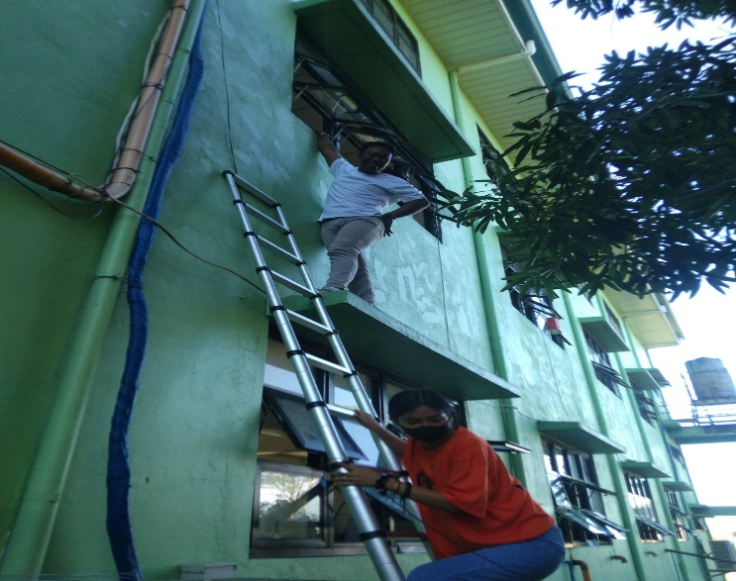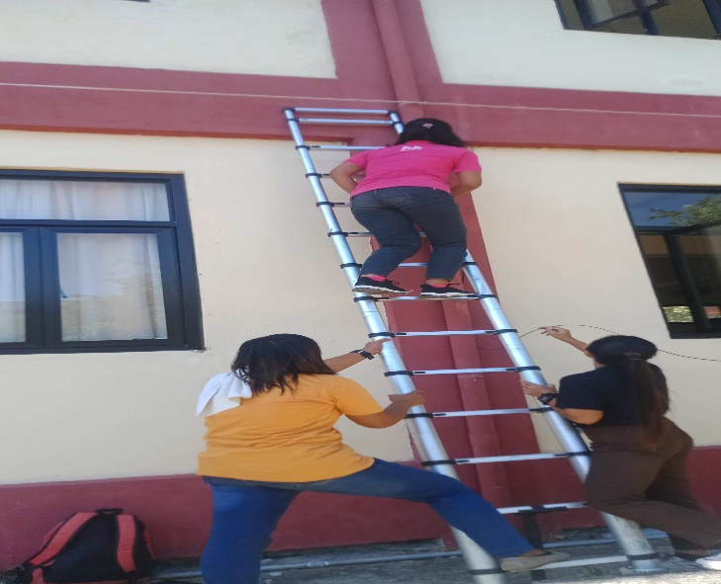

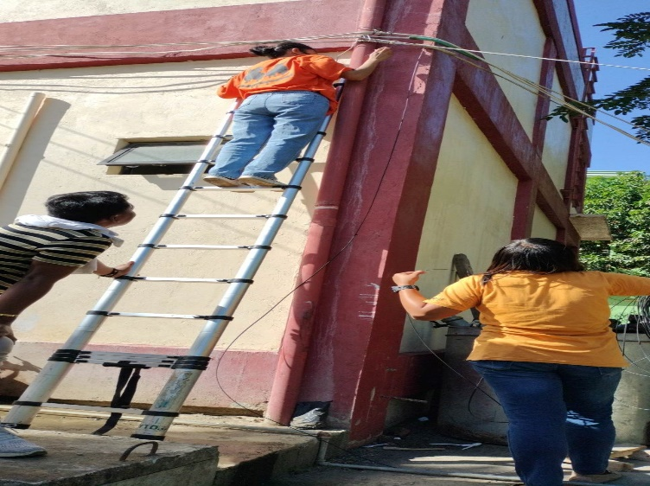

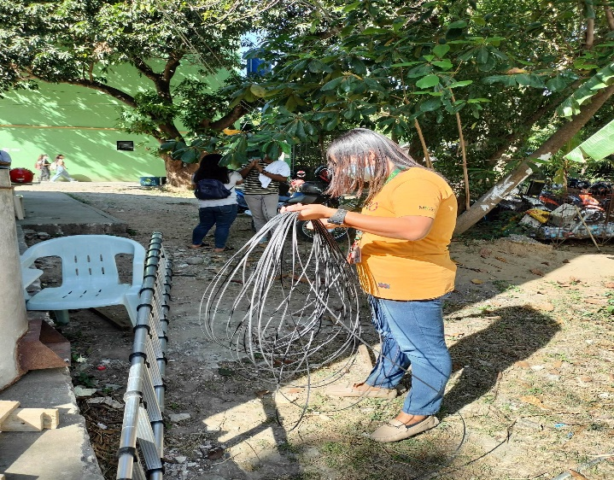

**MEMBERS:**

Rolly Viloria

Rowena Garais

Jasmaine Porquiso

Kristel Ann Pinto

Jasmine Joy Ferrer

**LIBRARY GROUP**

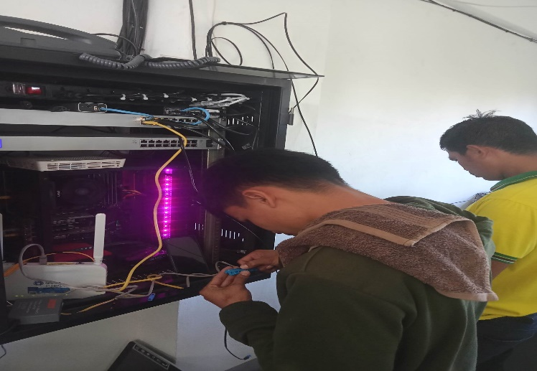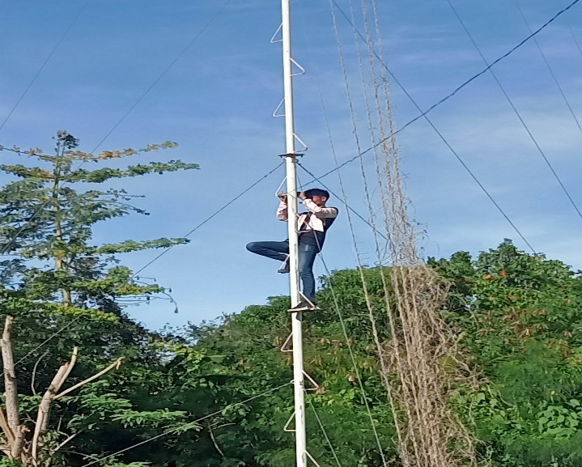

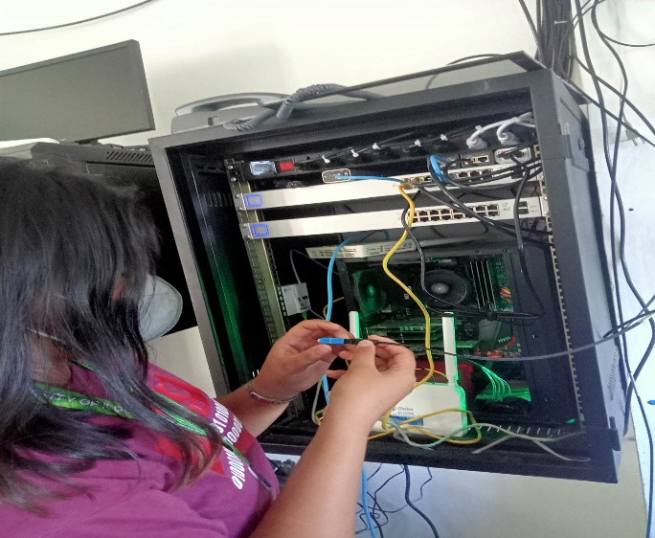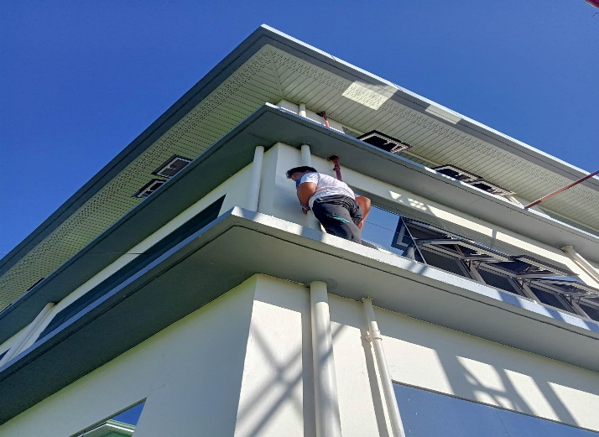

**MEMBERS:**

Diana Grace Francisco

Francis Estacio

Jobart Quijencio

Andrew Eiz James Kudera

**GRANDSTAND GROUP**

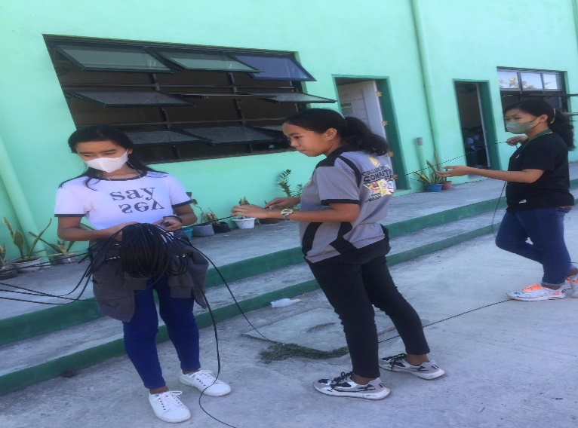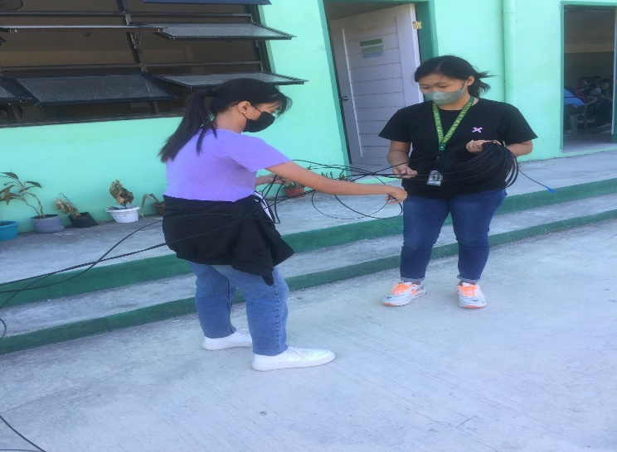

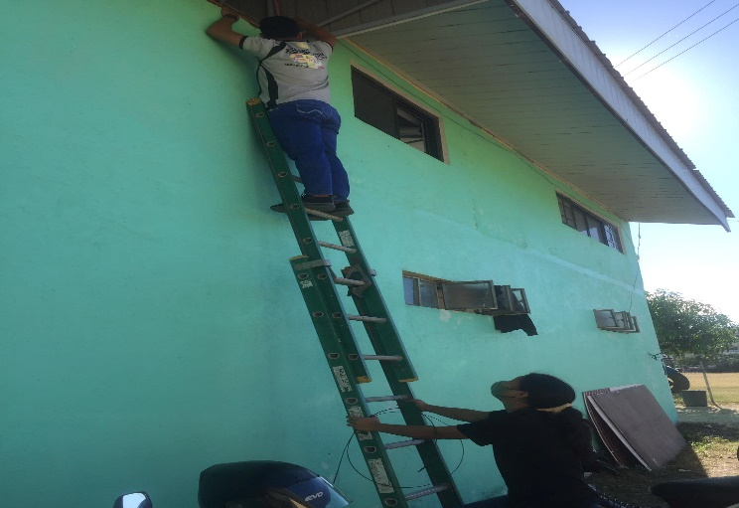

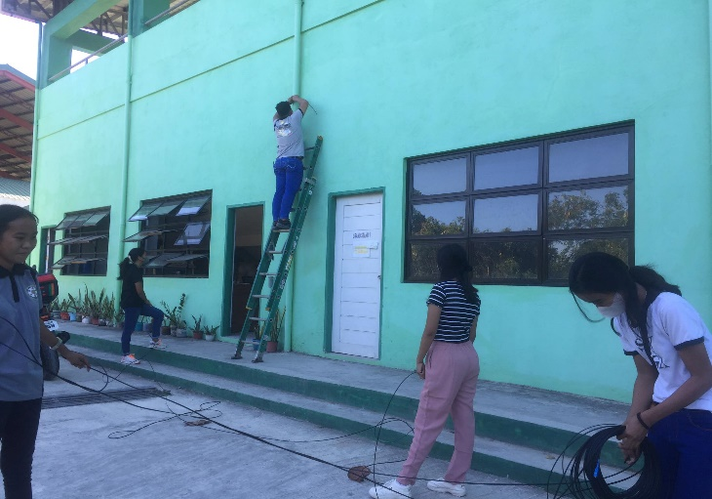

**MEMBERS:**

Daisy Lyn Gacusan

Benedict Tugade

Arabella Grace Domenden  
Jenny Villanueva

Gwyneth Aira Antonio  
Althea Rabadon

**REGISTRAR GROUP**

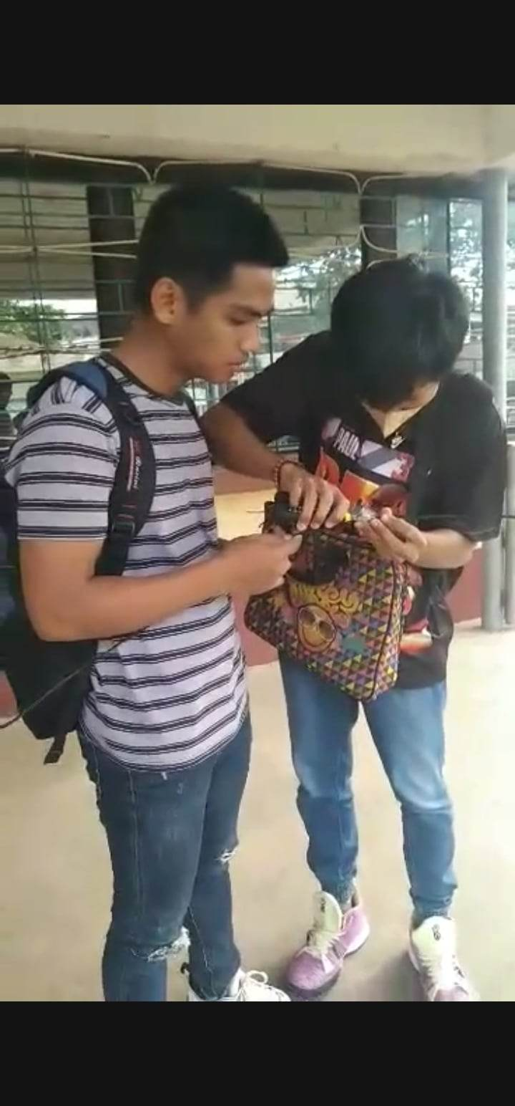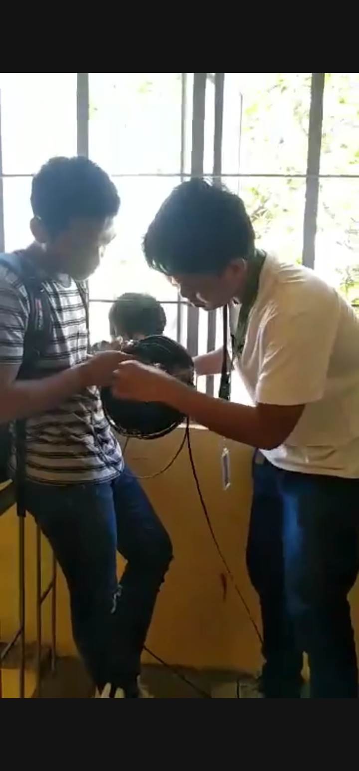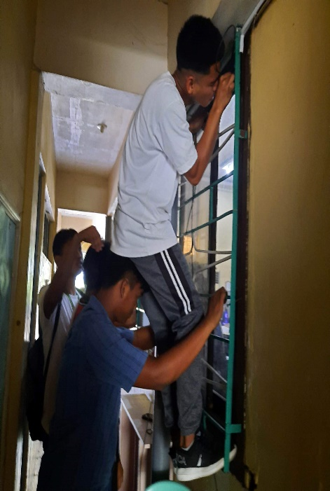

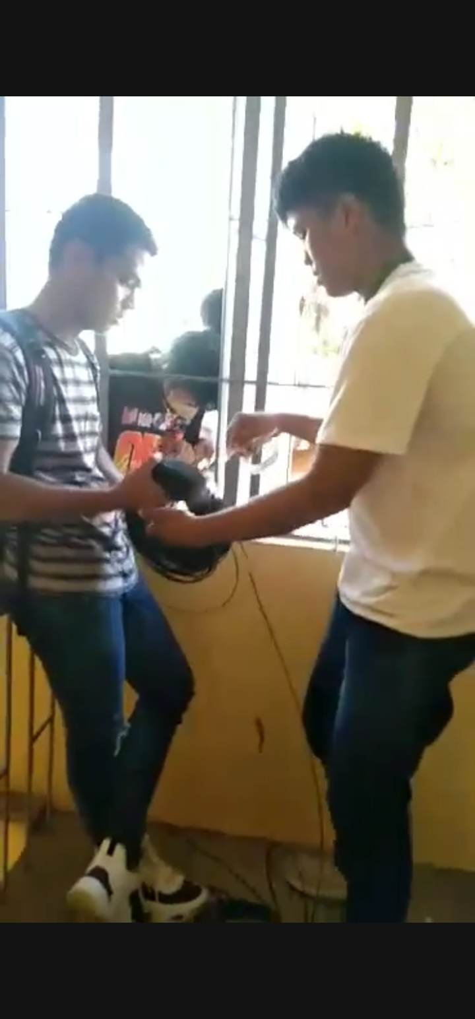

**MEMBERS:**

Melvin Langas

Laboriel Gabatino

Joriel Peralta

Arman Enriquez

John Paul Favo

**SANIDAD BUILDING GROUP**

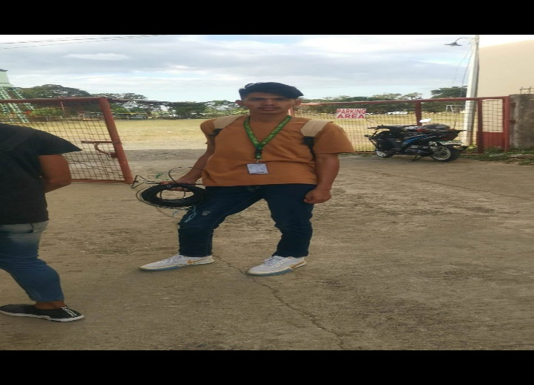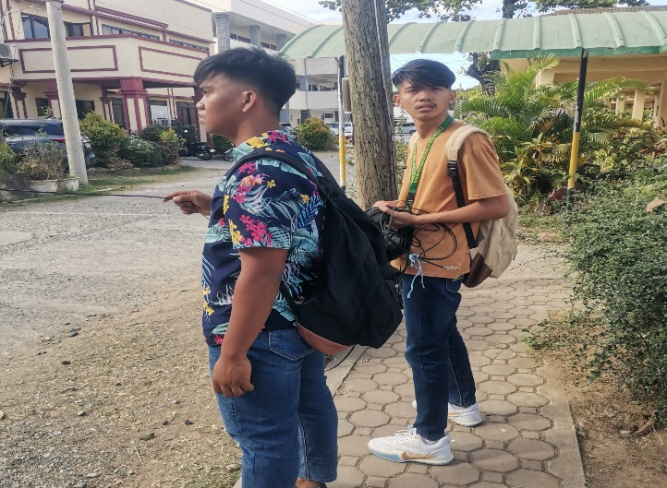

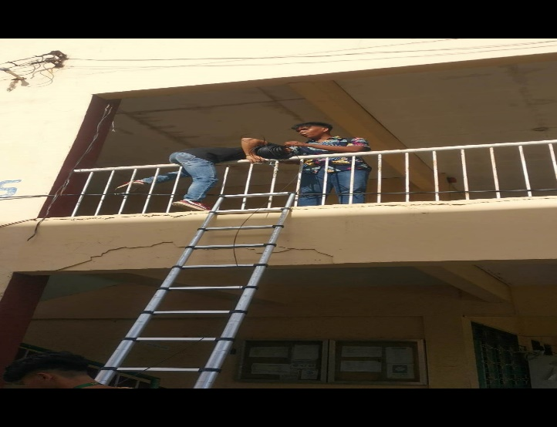

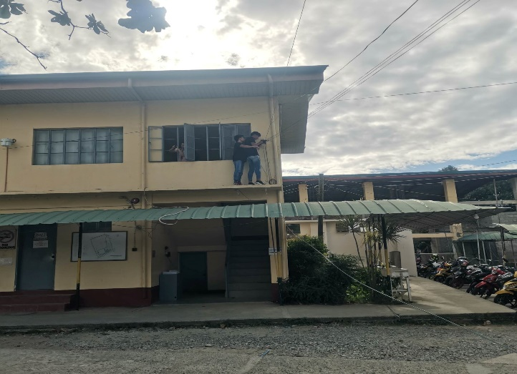

**MEMBERS:**

Rod Genesis Ramboanga

Frean Rendon

Jill Ariel Jalandoon Jr.

Renato Ramboanga

Kim Carlo Ray Ray

**LABORATORY OFFICE GROUP**

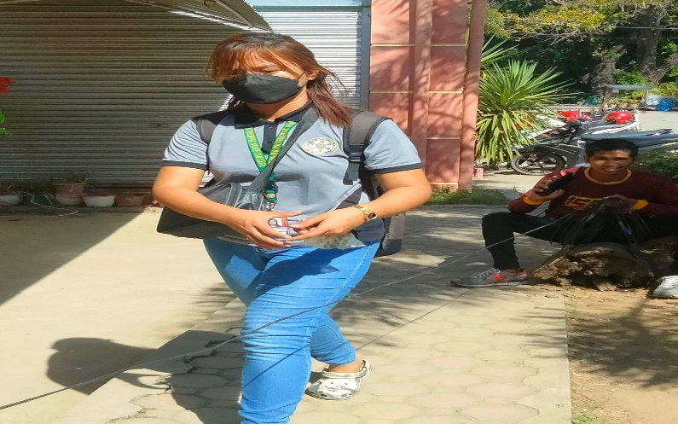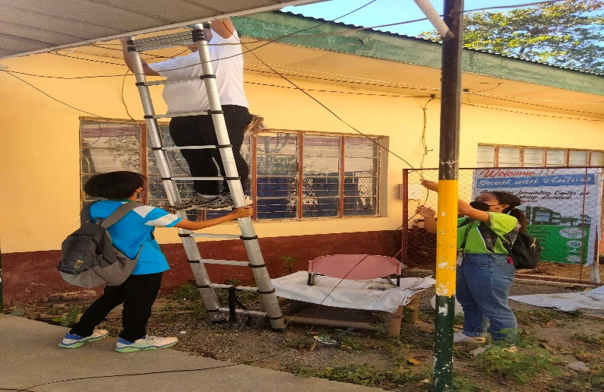

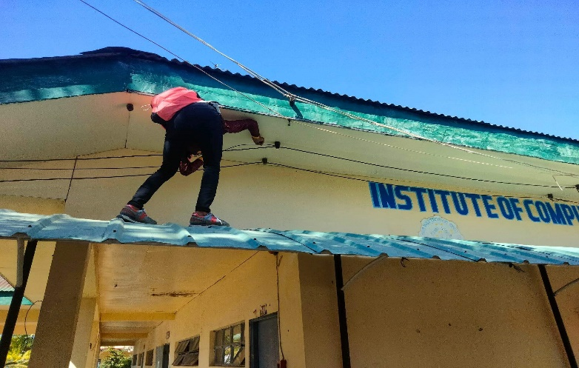

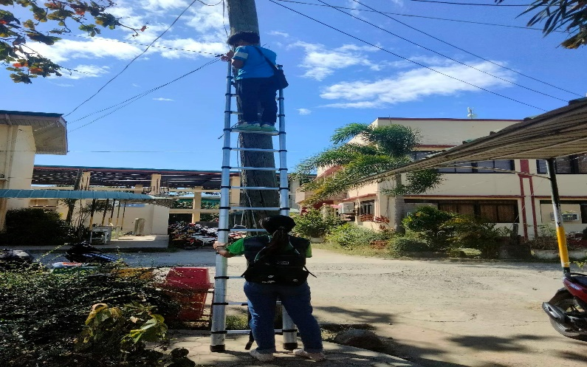

**MEMBERS:**

Justine Jade Isit

Leo Angelo Marco

Mark Joshua Somera

Michelle Angel Mercado

Anthea Marie Quitazol

**SCHOLARSHIP OFFICE GROUP**

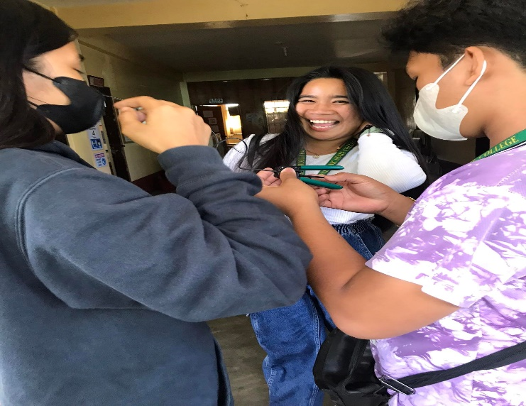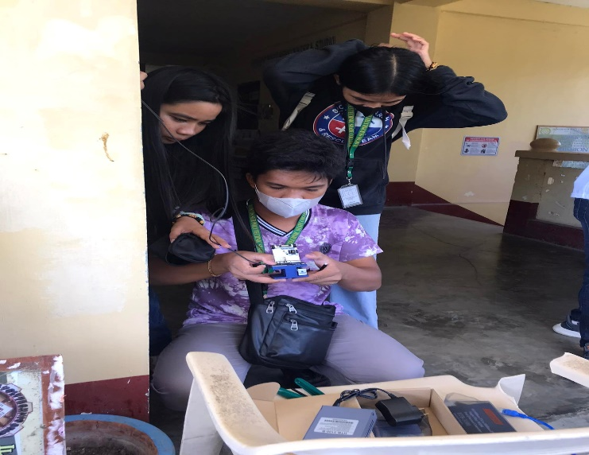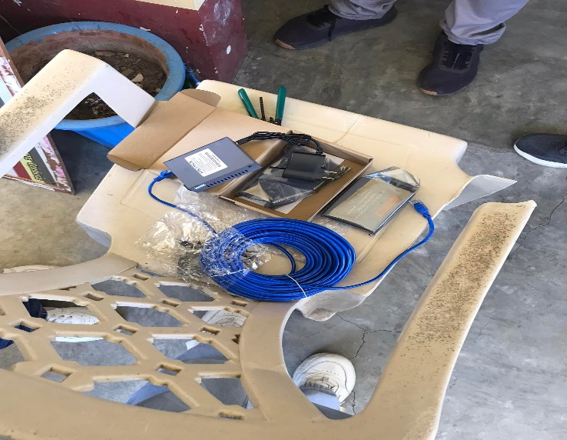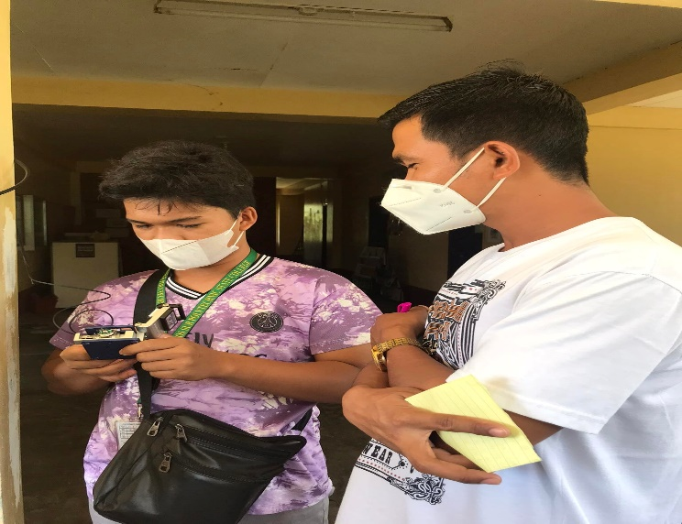

**MEMBERS:**

Russel Ramos

Ma. Eliza Ramirez

Krisalyn Domingo

Hannah miles Bello

**CASHIERS OFFICE GROUP**

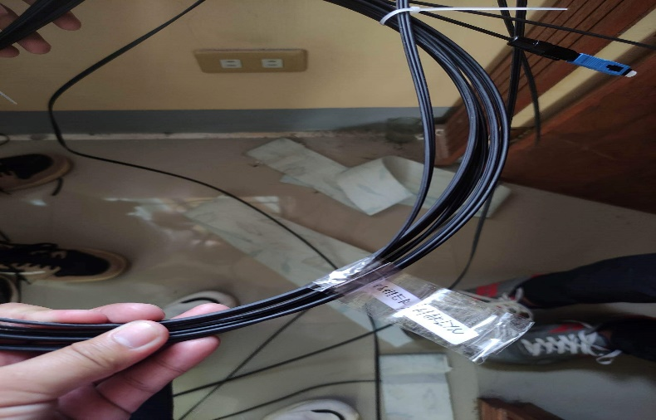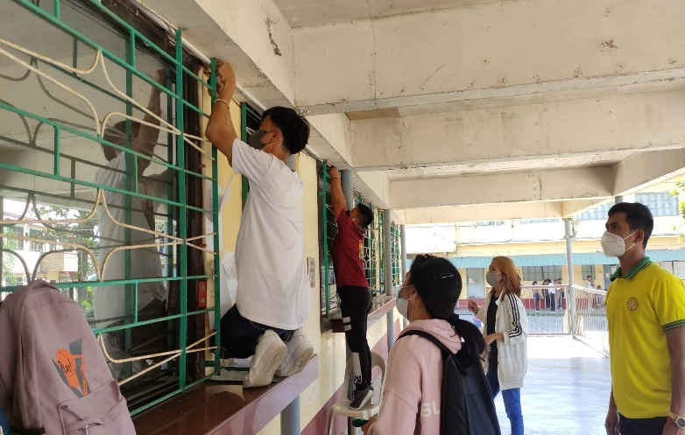

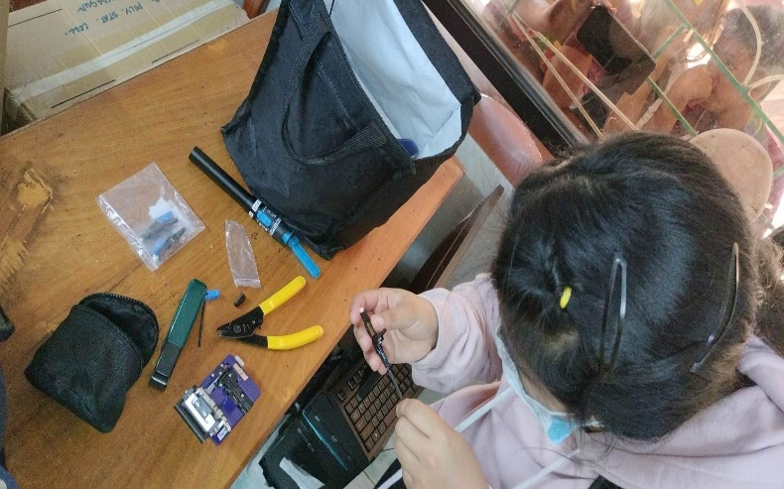

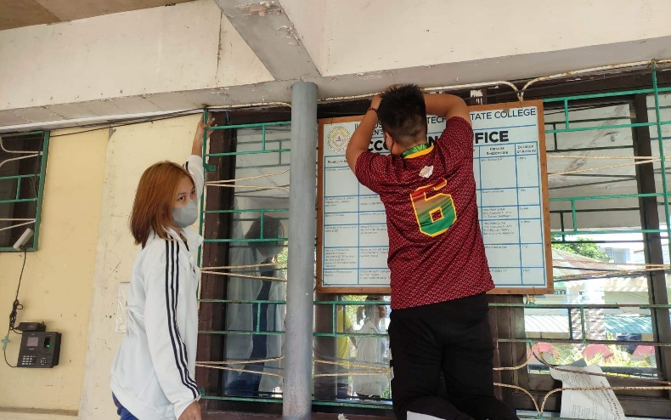

**MEMBERS:**

Tricia Joy Renon

Cherry Angel Diego

Nathaniel Santiago

Marlyn Rose De Fiesta

Angela May Inigo

**CLINIC BUILDING GROUP**

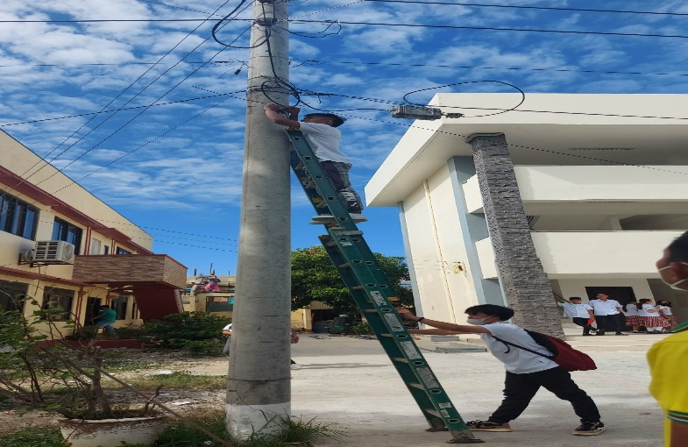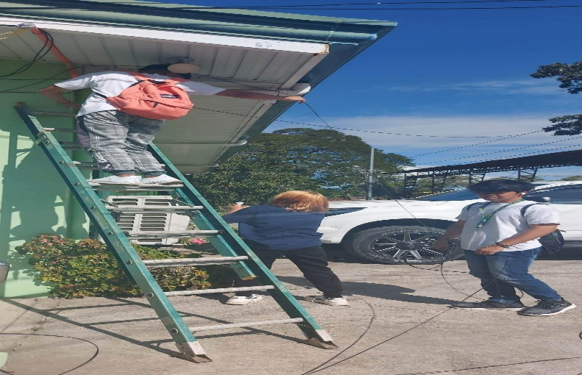

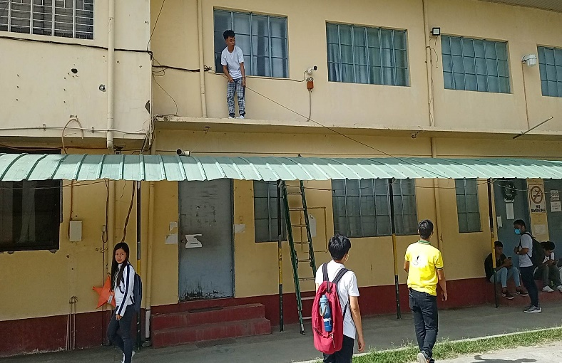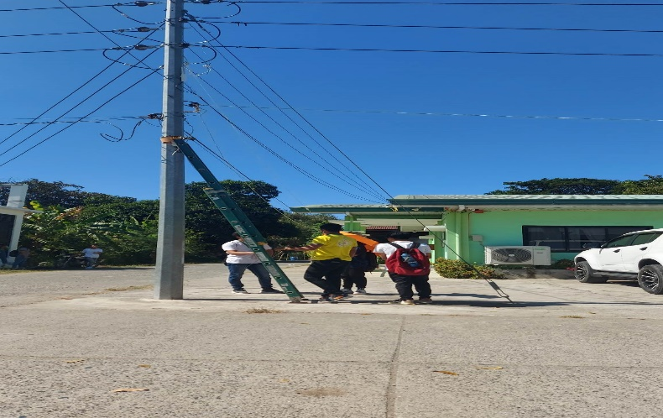

**MEMBERS:**

Christopher Jones Garcia

Jemar Nabubos

Edmalyn Valdez

Reymart Frio

Casselyn Rapanut